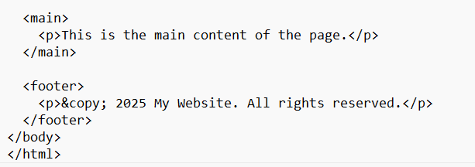
1. A web page is created using HTML, consists of various divisions which includes, head, body and
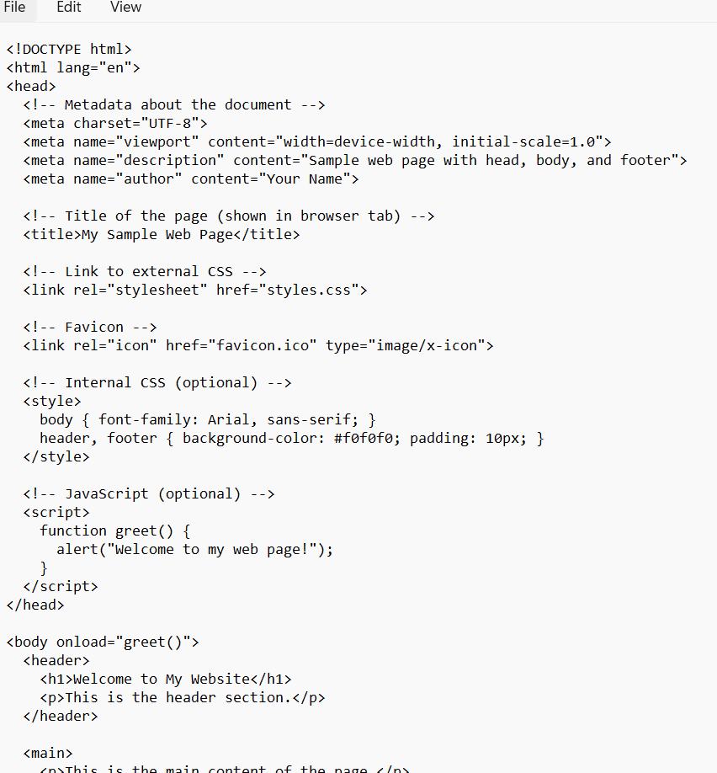
and footer parts. Write a program which includes various tags used inside the header tag.
Output
